Detecting Model Tampering in MLaaS Platforms Using Black-Box Probing

APPLICATION ARCHITECTURE

1.1 Selected Architecture:

Serverless + Event-Driven Architecture

1.2 Justification
- The system performs periodic monitoring of MLaaS models → fits event-driven triggers (cron, cloud scheduler).
- Black-box probing tasks are short-lived, so serverless functions reduce cost.
- Automatically scales when probe count increases.
- Serverless removes need for managing backend servers.
- Extremely suitable for API-based pipelines, where each stage is an event-triggered function:
  - Probe generation
  - API call
  - Fingerprint comparison
  - Tampering scoring
  - Alerts

1.3 Advantages
- Low cost → pay only when the function runs.
- Highly scalable
- Cloud-native
- Simple deployment
- Works well with diverse MLaaS services:
  - Hugging Face
  - Google Vertex AI
  - AWS SageMaker
  - Azure ML

MODULE ARCHITECTURE OVERVIEW

Core Modules
- Probe Generator – creates input probes for model fingerprinting.
- API Request Manager – sends requests to the MLaaS model.
- Fingerprint Builder – creates baseline fingerprints from API outputs.
- Tampering & Drift Detector – compares new outputs vs baseline fingerprints.
- Monitoring Scheduler – triggers periodic checks (e.g., every 30 minutes).
- Database Layer – stores fingerprints, responses, tampering scores.
- Dashboard Layer – displays integrity status & alerts.

3. USE CASE DIAGRAM
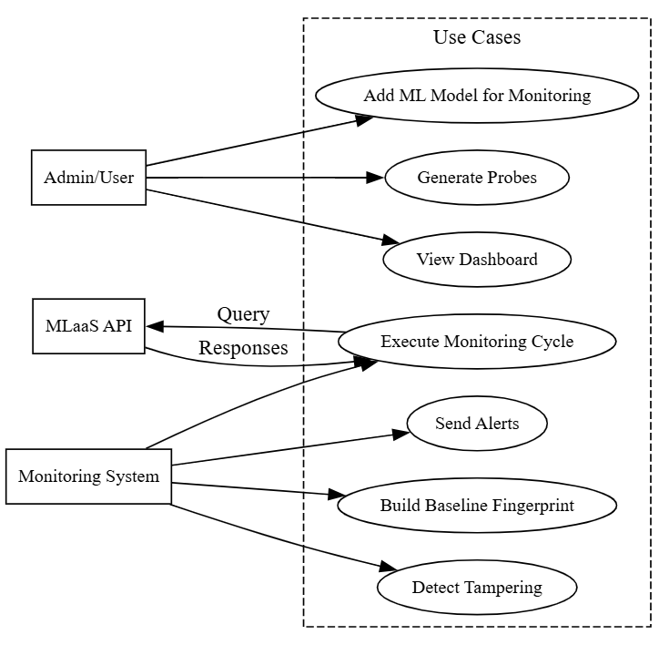
4. DFD LEVEL 0
5. DFD LEVEL 1
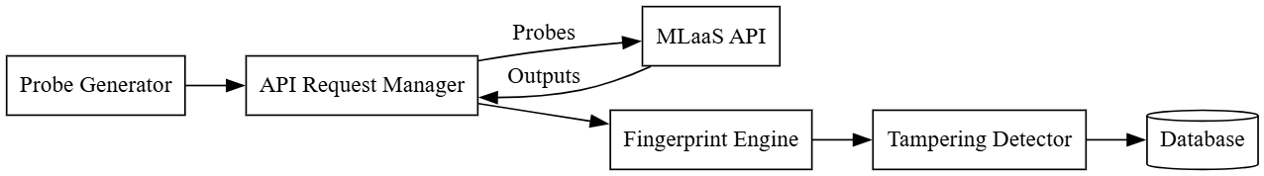

6. COMPONENT DIAGRAM
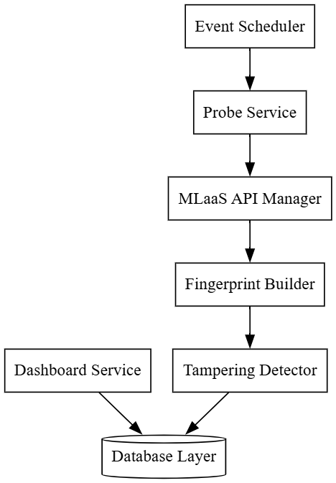

7. SEQUENCE DIAGRAM

8. DEPLOYMENT DIAGRAM
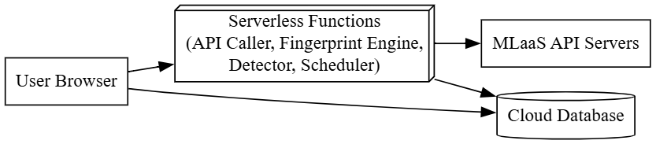
9. HIGH LEVEL SYSTEM ARCHITECTURE DIAGRAM
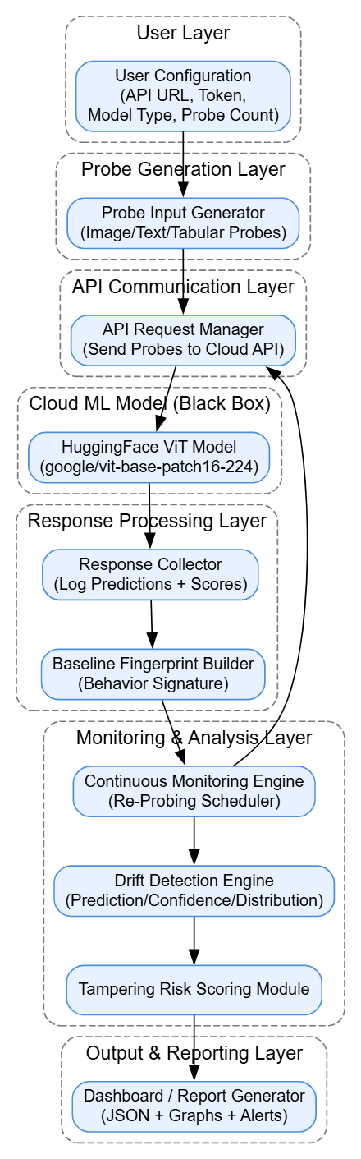
10. ER DIAGRAM

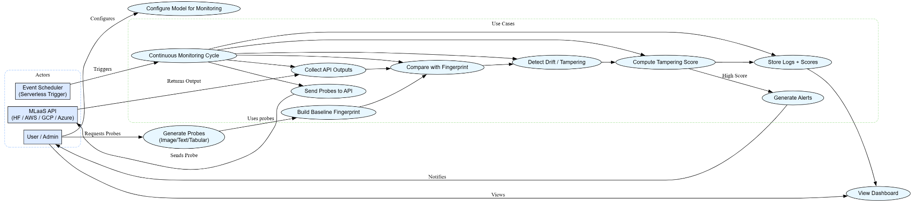

11. SCHEMA DESIGN
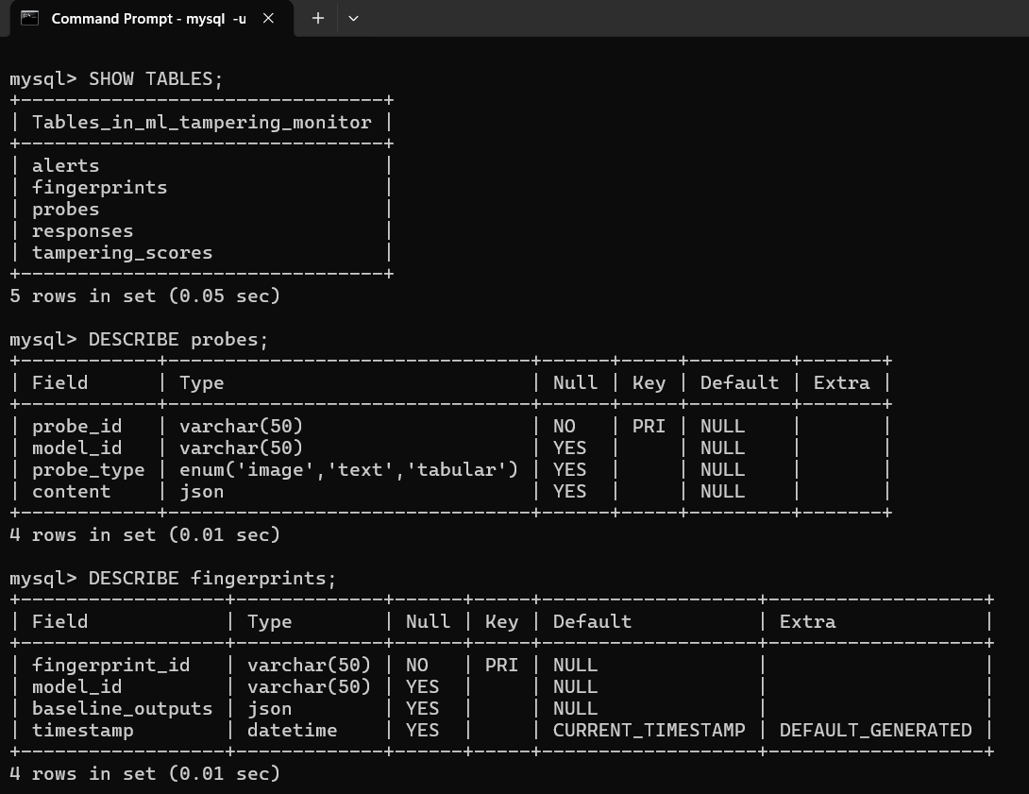
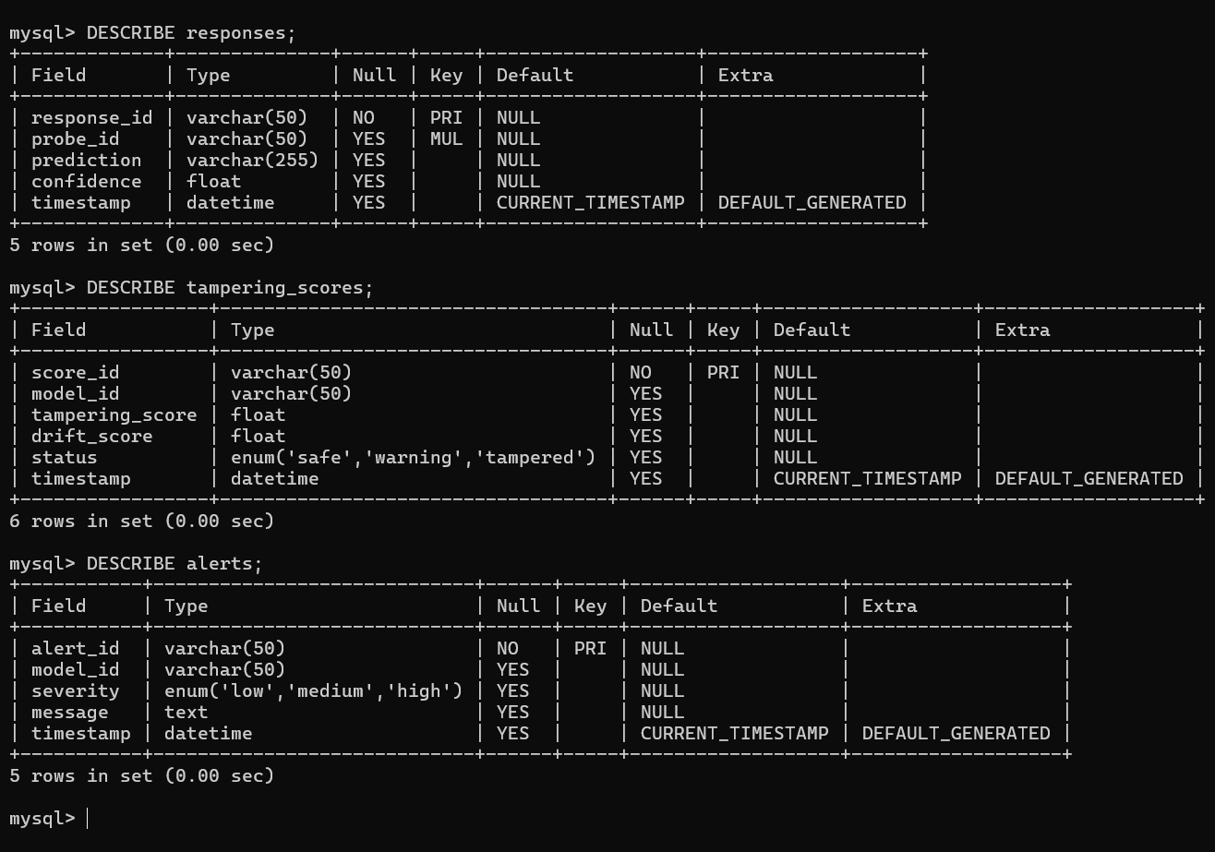

12. DATA EXCHANGE CONTRACT

12.1 Frequency of Exchange
- Baseline fingerprint → Once during setup
- Monitoring cycle → Every 15 min / 30 min / 1 hour

12.2 Datasets Exchanged
- probe_set.json
- baseline_fingerprint.json
- api_response.json
- tampering_score.json
- Alerts.json

12.3 Mode of Exchange

DATA | MODE
Probes → MLaaS | REST API (POST)
Probes → MLaaS | JSON (HTTP Response)
Storage | Database write
Dashboard | REST GET API
Alerts | Email

